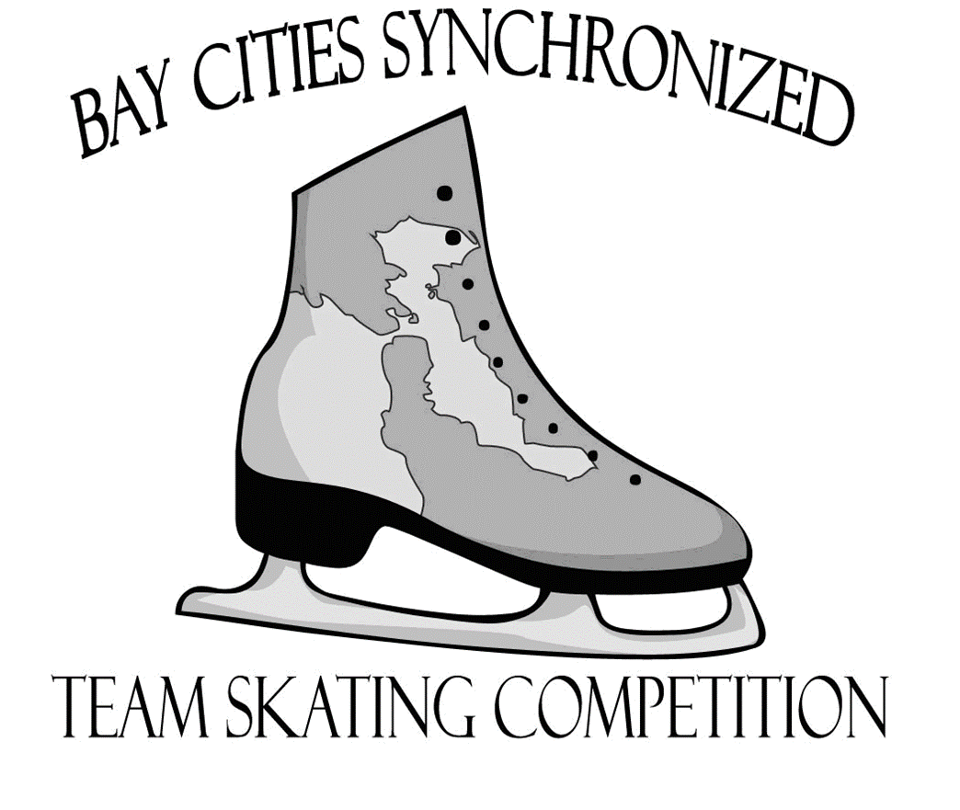

Sunday, January 8, 2017

To be held at

SHARKS ICE AT SAN JOSE
1500 S. Tenth Street
San Jose, California 95112

Entry Deadline: Entries must be received by December 1, 2016

.

2017 Bay Cities Synchronized Skating Competition

Endorsed by ISI
Sunday, January 8, 2017
9:00 am to 1:00 pm
Sharks Ice at San Jose, 1500 S. Tenth Street, San Jose, California

Eligibility

All skaters entering this competition must be registered individual members of ISI. All participating teams must be registered with the ISI office and have a valid team number for the 2016-2017 skating season.

Our goal is to provide an opportunity for teams to compete and to help the growth of team skating in all its forms. To further this goal, we are willing to be very flexible and make any accommodation that would allow more teams to participate. Please feel free to contact the Chief Referees, Candy Goodson and Lisa Erle or the Chair, Jean Fahmie and let us know how we can make this competition work best for you.

Entry Fees

The Entry Fees are: $17 per skater (Including Alternates) or $125 minimum
Minimum entry fee - $125
Special Skater event: No charge

One Team entered in a division will constitute an event.
Late entries will be accepted at the discretion of the Chief Referees and the LOC.
Completed entry forms and team rosters must be sent with appropriate fees.
Checks should be made payable to: St. Moritz ISC

Applications must be received no later than December 1, 2016, and mailed to the Registrar:

Jean Fahmie
2501 Pine Knoll Drive #16
Walnut Creek, CA 94595

Rules

The competition will be conducted in accordance with the guidelines contained in current version of the ISI Handbook with all current synchronized rule revisions.

Verification

All coaches must verify that all events and levels are correct before the application is submitted. The information on the entry form must be accurate, complete and legible.

Registration: The registration table will open one hour prior to the first event. The coach or contact person must check in at the Registration Desk one hour prior to the team’s event. Music should be turned in and picked up at Registration.

Bulletins & Notices: An Official Bulletin Board or wall space so designated will be maintained at Sharks Ice San Jose and will contain official information only. Notices posted here are considered sufficient notice to all entrants. Check frequently for any change in the schedule or other notices.

Practice Ice:

Teams requesting practice ice should contact Sharks Ice at San Jose, (408) 679-2000 or email Candy Goodson <cgoodson@sharksice.com>

Ice Surface

Sharks Ice at San Jose is a four surface ice rink. The Center Rink is 85’ X 200’ with slightly rounded corners and will be used for the competition. Practice ice purchased from the arena may be on the other surfaces.

Audience
Dressing Rooms
Photos Exit Judges Enter
xxx xxx

Ice Surface
85x200

Judges

Hotels

Hotels in the San Jose area:

- Double Tree San Jose
2050 Gateway Place
San Jose, CA 95110
(408) 453-4000

- Hyatt Place Downtown San Jose
282 Almaden Blvd.
San Jose, CA 95113
(408) 998-0400

- Hilton San Jose
300 Almaden Blvd.
San Jose, CA 95110
(408) 287-2100

, San Jose, California, 95110, USA TEL: 1-408-287-2100
- Embassy Suite Santa Clara
2885 Lakeside Drive
Santa Clara, CA 95054
(408) 496-6400

- Embassy Suites Milpitas
901 East Calaveras BLVD.
Milpitas, CA 95035
(408) 942-0400

Parking

The Sharks Ice San Jose has a large free parking lot.

Photography, Vendors and Fund Raising Tables

Absolutely no flash photography is allowed of competitors on the ice. The flash may cause distraction leading to error or injury.

Concessions may be purchased at the Sharks Ice snack bar in the lobby or at Stanley’s Restaurant and Bar.

Music

- Competition music must be turned in at the registration desk and must be submitted no later than one hour prior to the event in which the team is skating.
- Only CDs will be accepted. CDs must be clearly marked with team name, event entered and the music length and contained in paper or soft plastic CD case.
- There should be only one track per CD.
- All teams must have an additional copy of their music available for practice sessions.
- Teams must also have an extra copy available quickly during the actual competition event.
- Music should be picked up at the registration desk shortly following the conclusion of the event. The St. Moritz ISC is not responsible for music that is not picked up.

.

Admission: No admission fee will be charged.

Schedules

We will attempt to email schedules out at least two weeks prior to the competition. The schedule will also be made available on the club website www.stmoritzisc.org and will be updated as necessary. PLEASE NOTE THAT THE FINAL SCHEDULE WILL BE POSTED THE DAY OF THE COMPETITION AND ANY SCHEDULES DISTRIBUTED BEFORE THAT ARE TENTATIVE.

Judging

All coaches with teams competing in the competition must be current ISI Professional Member. All participating rinks are required to supply an appropriate number of certified judges. All professional memberships and judge certification will be verified by ISI.

Awards and Trophies

1st through 4th place medals will be given to each skater and alternate. Medals will be distributed at the registration desk immediately after results are posted.

Five special team trophies will be presented. Every team in the competition will be eligible to compete for the trophies. No team will be awarded more than one trophy.

The special awards are as follows:

- Artistic Award – given to the team with the most entertaining program. Audience reaction, costuming, composition, presentation and style will be considered.
- Technical Merit Award – given to the team with the best skating ability as a team.
- Best Team Award – given to the best team at any level representing an ISI program.
- Judges Choice Award – criteria to be decided by event judges.
- Team Spirit Award – awarded by Local Organizing Committee.

Team Trophies will be awarded at the conclusion of all the events.

Information

For any questions or additional information on the competition, please contact the competition chair,
Jean Fahmie
925-464-7676 or 510-378-4928
jfahmie@gmail.com

Events Offered

Synchronized Formation Synchronized Formation Compulsories

Synchronized Skating Synchronized Skating Compulsories

Advanced Formation Production and Theater Production

Ensemble Team Synchronized Dance

Special Skater Production Team Surprise

Team Age Divisions –
Events are offered to all ages - Tots through Adults

Teams will be divided by the following age groupings (age as of 7/1/15)

Tot Teams Majority of skaters age 6 and under
Jr. Youth Teams Majority of skaters age 8 and under
Youth Teams Majority of skaters ages 9-11
Sr. Youth Teams Majority of skaters ages 12-14
Teen Teams Majority of skaters ages 14-19
Collegiate Teams Majority of skaters 18-25 and are affiliated with the college/university they are representing
*Adult Teams Majority of skaters age 20-39
*Masters Teams Majority of skaters age 40 or older

*may be combined at the discretion of the competition director.

Description of Events

Synchronized Formation Compulsories

Teams perform each required element once to music of their choice. Each element below is to be performed only one time in any order. If performed more than once, the first performance will be scored. Extra elements can be performed but will not be judged.

- Forward Skating Line
- Forward Circle
- Forward Two-Spoke Wheel
- Forward Skating Block

Program length: 1:45

There is no penalty for skating under the prescribed time.
Please see the 2010 ISI Handbook for additional rules and restrictions.

Synchronized Formation

Groups of 8-24 skaters performing various formations such as wheels, circles, lines, blocks, etc in a program to music (vocals acceptable). The program should consist of basic skating skills with a minimum of simple footwork, hops and toe steps. The team should demonstrate a good knowledge of synchronized basics such as unison, straight lines and correct holds. Teams demonstrate synchronized basics using any forward steps, such as forward marching (not loud stomping), forward half swizzles or pumps, and backward skating on two feet only. A two-foot turn must be used if two-foot backward skating is done, since a mohawk turn would be illegal. Only two-foot backward skating is allowed such as backward pumps. Backward chasses, backward progressives, backward crossovers, backward marching and Mohawks are all illegal one-foot backward skating moves. No props are allowed. The Formation team program must include at least one of each of the following basic elements: Line, Circle, Block, Wheel and Intersection using any forward skating steps and backward skating on two feet only.

Programs Length:

Tots 3:00 (10 sec. leeway)
Jr. Youth 3:30 (10 sec. leeway)
Youth 3:30 (10 sec. leeway)
Sr. Youth 3:30 (10 sec. leeway)
Teen 4:00 (10 sec. leeway)
Collegiate 4:00 (10 sec. leeway)
Adult/Masters 4:00 (10 sec. leeway)

There is no penalty for skating under the prescribed time

Advanced Formation

This new team category is for skaters who are continuing to master the basics of good synchronized skating such as straight line, correct holds and unison. The program must include at least one of each of the following basic elements: Line, Circle, Block, Wheel and Intersection. Skaters are permitted to skate backwards on one foot but are limited to using only 3-turns and Mohawks for turning and in footwork sequences.

Program length: Same as Synchronized Formation category.

Synchronized Skating

Groups of 8-24 skaters who have already mastered the basics of good synchronized skating and are executing superior synchronized formations with speed, difficulty, and accuracy. The program to music (vocals allowed) should contain synchronized moves along with edges, intricate footwork and a minimum of two-foot skating. There should be a minimum of stops (or pauses). Skaters should strive for continuous movement throughout the program with smooth transitions, and give the impression that it was done effortlessly. Small jumps or hops, technically difficult turns and connecting moves (i.e., brackets, Choctaws, arabesques, Bauers, etc.) are encouraged. Skating teams use forward and backward skating steps such as chasses, progressives and crossovers along with maneuvers such as backward splicing, backward eggbeaters, wheels, blocks and lines. Unison, cleanness and speed are expected

No props allowed.

Lifts are permitted in the teen skating event only. Lifting hands may not extend higher than the head of the lifter.

The Skating team program must include at least one of each of the following basic elements: Line, Circle, Block, Wheel and Intersection using forward or backward skating steps.

Program length:
Tots 2:00 (10 sec. leeway)
Jr. Youth 2:30 (10 sec. leeway)
Youth 3:00 (10 sec. leeway)
Sr. Youth 3:30 (10 sec. leeway)
Teen 4:30 (10 sec. leeway)
Collegiate 4:30 (10 sec. leeway)
Adult/Masters 3:30 (10 sec. leeway)

There is no penalty for skating under the prescribed time

Synchronized Skating Compulsories

Teams perform each required element once to music of their choice. Each element below is to be performed only one time in any order. If performed more than once, the first performance will be scored. Extra elements can be performed but will not be judged.

- Line
- Footwork Block
- Circle
- Wheel
- Intersection

Program length: 2:30

There is no penalty for skating under the prescribed time.
Please see the 2010 ISI Handbook for additional rules and restrictions.

Synchronized Dance

Groups of 8-24 skaters all move in unison, utilizing dance steps – tap, soft shoe, ballet, etc, - and skating moves to produce a program. These teams may resemble Broadway and showy types of routines similar to the Radio City Rockettes. Hand-held props are permitted in this event. Lifts are allowed in Teen Dance events only. Lifting hands may not extend higher than the head of the lifter.

Program length:
Tots: 2:00 (10 sec. leeway)
Jr. Youth 2:30 (10 sec. leeway)
Youth 3:00 (10 sec. leeway)
Sr. Youth 3:30 (10 sec. leeway)
Teen 4:30 (10 sec. leeway)
Adult/Masters 3:30 (10 sec. leeway)
There is no penalty for skating under the prescribed time

Ensemble Team

Open to groups of 3-7 skaters of all levels and ages. One mark will be given for performance value of the program. There are no required maneuvers and no technical score, but any skating maneuvers can be performed. The group must use the music with costumes and props to enhance the theme. Props & scenery permitted

Length of program 3:00 (10 sec. leeway)

There is no penalty for skating under the prescribed time

Production

This is a lavish, creative, artistic work marked by extreme freedom of style and structure, using costumes and props to illustrate the number. Any and all types of skating maneuvers are permitted including jumps and spins. Props & scenery permitted. For skaters of all ages and ability.

Length of program: 4:30

There is no penalty for skating under the prescribed time

Theatre Production Team

This category is for your entire skating team. Skaters of all ages and advanced ability level can
participate in this exciting new team event. Team entries are grouped by numbers of skaters first
and then by age and/or level of participants, if necessary.

Length of program: 6:30

There is no penalty for skating under prescribed time.

SECTION 2: SPECIAL EVENTS

Special Skater Production/Theater on Ice Team:

Open to groups of any number of Special Needs Skaters and helpers performing to music. Walker and other assistive devices as needed. Props and scenery permitted. One mark will be given. All Skaters will receive an award.

Program length: Up to 4:30 – plus time to get the skaters on and off the ice.

2017 BAY CITIES SYNCHRONIZED SKATING COMPETITION

January 8, 2017

ENTRY FORM 1: Team Information (One form per event please)
Team name: |  | Team ID #:
Rink:

Team contact person:

Daytime phone number: | E-mail:
Address: | City |  | State / ZIP
Primary coach: |  | ID #
Daytime phone number: | E-mail:
Number of skaters: | Number of alternates:
Length of Program: | Skaters cross over to following event:

Please check the level and/or event entered:
Synchronized Skating Synchronized Formation
Synchronized Skating Compulsories Synchronized Formation Compulsories
Advanced Formation Synchronized Dance

Age Category (majority) Teen (14-19)
Tot (6 & Under) Adult (20-39)
Jr. Youth (8 & Under) Master (40+)
Youth (9-11) Collegiate (18-25 with university affiliation)
Senior Youth (12-14)

Special Skater / Special Needs

Production Ensemble Team Theater Production Team

ENTRY FEES: # of skaters @$17 = $ _________
(Minimum entry fee - $125)

St Moritz Ice Skating Club
Checks should be made payable to:

Jean Fahmie
2501 Pine Knoll Drive #16
Walnut Creek CA 94595
Please send all forms and fees to:

All fees and entry forms must be

December 1, 2016
received by:

2017 BAY CITIES SYNCHRONIZED SKATING COMPETITION

ENTRY FORM 2: Team Entry Form

Team Name:

Club/Rink Name:
Coaches:
Event / Level
Place an asterisk (*) next to each skater who crosses over to another team and identify the other team.
Please highlight any skater of Novice level and above that have skated in a US National Championship within the last 2 years.

SKATER NAMES IN ALPHABETICAL ORDER  Last name first | Birth date | ID #
1.
2.
3.
4.
5.
6.
7.
8.
9.
10.
11.
12.
13.
14.
15.
16.
17.
18.
19.
20.
Use additional pages if necessary

Certification by Officer of Sponsoring Organization: All skaters, including alternates, listed on the team roster are members of the _____________________(club/team) for the 2016-2017 season and are, to the best of my knowledge, eligible persons and are members in good standing of this club/team and are eligible to compete under U. S. Figure Skating rules governing this competition. U. S. Figure Skating, the St. Moritz Ice Skating Club and/or Sharks Ice San Jose will not be held liable for any injuries occurring during this competition.

Print name of Officer Signature Title Date

