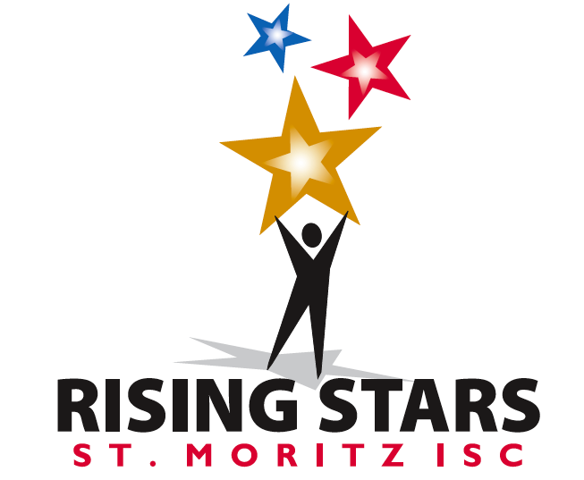

Club Competition
Saturday, March 19th, 2016
Oakland Ice Center
12:45 – 4:15 PM

Events Include:

- Basic Skating
- Free Skate through
Preliminary level

- Artistic
- Special Skater
- Pairs
Club Competition

Hosted by St Moritz Ice Skating Club
and
Sharks Ice Oakland

Chief Referee: Lisa Erle
Accountant: Jean Fahmie
Competition Chair: Phillip DiGuglielmo

Application Deadline: March 4, 2016
We are proud to announce our third Rising Stars Competition. The goal of this event is to introduce beginner skaters to the fun and excitement of competition and to further their development into life long lovers of skating. This has been made possible by a grant of the US Figure Skating and the Robert V. Hauff & John F. Dreeland Foundation and the Sharks Ice Oakland.

Eligibility and Rules
The Rising Stars competition is open to members of the St. Moritz Ice Skating Club. For further information about club membership please contact Jean Fahmie at jfahmie@gmail.com. The competition will be conducted in accordance with the rules of U.S. Figure Skating. This competition will be governed by all rules applicable to the 2015-2016 competitive season except as noted in this announcement. All events will use the 6.0 system of judging. Skaters will compete in events as qualified by their age and test level as of March 4, 2016 or at one level higher. Skaters will be grouped in events by age. In the event that a skater is signed up for the incorrect level or event, the Chief Referee must approve all changes.

Awards
All award ceremonies will be held off-ice in the arena shortly after the final results are posted. Medals will be given to all skaters regardless of placement.

Fees
Through cooperation with Sharks Ice Oakland and the St Moritz Ice Skating Club the competition has been able to reduce entry fees this year. According to Rule 3047, entry fees are refundable only if the competition is not held or if withdrawal of an entry is made before the closing date.
The Competition Fees are as follows:
Any U.S. Figure Skating Event $40
Any Second U.S. Figure Skating Event $10
Any Third U.S. Figure Skating Event $10
No refunds under any circumstances (including medical) after closing date unless the event is cancelled for lack of participation. Late entries will be accepted only at the discretion of the Chief Referee and must be accompanied by a $25.00 late fee.
Entries may need to be limited for time.

Music
Only CDs will be accepted and must be clearly marked with the competitor’s name. CDs must have only ONE track on it. Music must be turned in at the registration desk when checking in for the competition. Music may be picked up at the registration desk after completion of the event. Please have extra copies of your music available at the event in case of there is a problem with the original.

Coaches’ Registration - SAFESPORT
In accordance with current rules, all coaches participating in this event must be registered with U.S.Figure Skating. For more information on the registration process, please visit www.usfigureskating.org. We will provide all registered coaches with a credential. Every coach in attendance will be required to check in at the registration table and MUST show a picture I.D. We strongly recommend that you also bring any registration confirmation materials. Once credentialed, coaches must wear his/her badge at all times when at rink-side. Coaches must wear their badge at all times when coaching skaters at rink side of a sanctioned competition. Monitors will be instructed to ensure that anyone standing rink side has their credential.

EVENT DESCRIPTIONS

BASIC SKATING (levels 1 through 5)

Groups will not be divided by gender except at the discretion of the Chief Referee, if appropriate. Groups will be divided by age when more than 4 are entered or when appropriate at the discretion of the Chief Referee.

Competitors will perform a program to music with the prescribed elements. One mark will be awarded for the overall program, elements and presentation. Skaters will receive a 0.2 deduction for additional elements from higher levels.

Event | Description / Elements | Tests / Age Requirements | Duration (Min:Sec)
Basic Skating 1 | Elements to be skated:  - Marching while moving;  - Two foot jump in place  - Forward swizzles from standstill (3 times)  - Moving forward swizzles (3 times)  - Forward two foot glide  - Elements may be skated in any order. Minimal connecting steps are allowed. No additional elements are permitted. | Open to skaters who have not passed any U.S. Figure Skating Moves in the Field or Free Skate tests. | 1:00  +/- 10 seconds
Basic Skating 2 | Elements to be skated:  - Snowplow stop – one or two foot  - Forward swizzles: 5 - 6  - Back Wiggles or Back Swizzles: 5 - 6  - Dip - Deep knee bend while gliding, 2 feet  - Forward One Foot Glide - Left & Right  - Two foot turn from forward to backward from standstill  - Elements may be skated in any order. Minimal connecting steps are allowed. Elements from Basic Skating 1 may also be included, but no elements from higher levels permitted. | Open to skaters who have not passed any U.S. Figure Skating Moves in the Field or Free Skate tests. | 1:00  +/- 10 seconds
Basic Skating 3 | Elements to be skated:  - Forward Outside Edges - 1-2 each foot  - Forward Inside Edges - 1-2 each foot  - Backward glide on 2 feet  - Bunny Hop - max 3  - Shoot the Duck or Lunge - Right or Left  - Forward inside 3-Turns - R & L from standstill  - Elements may be skated in any order. Minimal connecting steps are allowed. Elements from Basic Skating 1 or 2 may also be included, but no elements from higher levels permitted. | Open to skaters who have not passed any U.S. Figure Skating Moves in the Field or Free Skate tests. | 1:00  +/- 10 seconds
Basic Skating 4 | Elements to be skated:  - Forward Crossovers – Clockwise & Counter-clockwise (min 4 each);  - Forward Inside Mohawk followed by extended backward outside edge;  - Waltz Jump;  - Two Foot Spin – entry optional;  - Forward Inside Pivot;  - T-Stop – either foot  - Elements may be skated in any order. Minimal connecting steps are allowed. Elements from Basic 1, 2 or 3 may also be included, but no elements from higher levels permitted. | Open to skaters who have not passed any U.S. Figure Skating Moves in the Field or Free Skate tests. | 1:00  +/- 10 seconds
Basic Skating 5 | Elements to be skated:  - Backward Crossovers –  Clockwise & Counterclockwise (min 4 each)  - Backward outside edges: 1-2 each foot  - Forward Spiral – either edge or flat  - One Foot Spin – free leg optional  - Waltz Jump  - Half-Flip  Elements may be skated in any order. Minimal connecting steps are allowed. Any elements from lower levels may be included. | Open to skaters who have not passed any U.S. Figure Skating Moves in the Field or Free Skate tests. | 1:00  +/- 10 seconds

SINGLES - FREE SKATING
Limited Events: Skaters will receive a 0.2 deduction for performance of any element outside the set limits.

Warm-up groups are 6 maximum unless otherwise noted.

Limited No  Test FS  Warm-up groups may be 8 maximum  Formerly:  Pre-Preliminary 1 | - Max 5 jump elements, with max of two jump combinations or sequences. Number of jumps in a combination is 2; number of jumps in a sequence is 3 max.  - Max 2 spins  - 1 step sequence using ½ the ice surface  LIMITED EVENT:  Allowed jumps are waltz, Salchow, toe loop, and all half jumps except half-loop only. Loop, flip, and Lutz are not allowed. Maximum of two of any same type jump.  Allowed spins are upright or sit only.  Spins may not have a flying entry. | No age restrictions.  Open to skaters who have not passed their Pre-Preliminary Free Skate test.  No test required. | 1:30  +/- 10 seconds
No Test  Formerly:  Pre-Preliminary 2 | Program as per rule 4280 | No age restrictions.  Open to skaters who have not passed their Pre-Preliminary Free Skate test.  No test required. | 1:30  +/- 10 sec
Pre Preliminary  Formerly:  Pre-Preliminary 3 | Program as per rule 4270. | No age restrictions.  Passed no higher than the US Figure Skating Pre-Preliminary Free Skate Test.  No test is required. | 1:30  +/- 10 sec
Preliminary FS | Program in accordance with Rule 4260.  See Required Elements Chart for Preliminary FS on the U.S. Figure Skating website, Technical Info tab. | Open to skaters who have passed their Pre-Preliminary FS test, but not their Pre-Juvenile FS test.  No age restrictions | 1:30  +/- 10 seconds

SHOWCASE SKATING EVENT

Showcase events may either be Dramatic or Light Entertainment in style. These programs should utilize intense emotional skating quality, comedy, love, a particular character and/or other concepts while incorporating skating skills to depict a choreographic theme. Props and scenery are not permitted.
Levels offered are the same as for free skate. Groups will not be divided by gender. Levels may be combined at the discretion of the Chief Referee if entries warrant
Programs are 1:40 maximum length.

SPECIAL SKATER EVENT
Skaters in any Special Skater program of any level, either singles or pairs or groups may enter. Skaters may perform with assistance (including assistive devices or coach assistance) or without. Vocal music is permitted. Program duration should be 1 to 1-1/2 minutes.

PAIRS EVENT
Coaches and skaters interested in competing in this event should contact the competition chair directly for requirements and program specifications.

